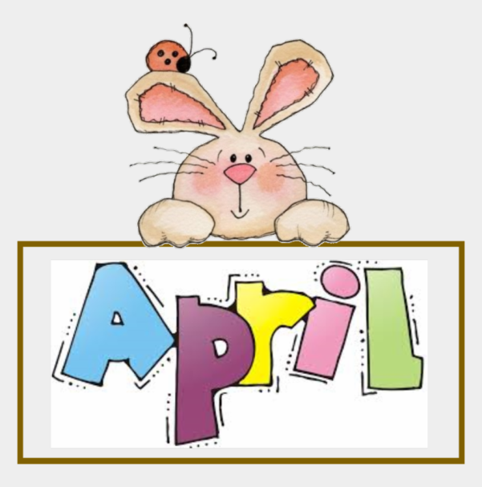
Theme: Myself and My Body Parts
Montessori Activities: Folding and unfolding napkins (EPL)
Written work:
Drawing insets ( Circle /colour red)
Craft Activity
Critical Thinking/Sensorial Activity: In / Out, Happy / Sad
Circle Time Activities :
- Conversation
- Rhyme Time
- Learning Values
- Outdoor Activity
- Story Time
Theme : My Family,Helpers and My Neighbourhood
Montessori Activities : Rolling and unrolling mat(EPL),
Hot and cold activity(Sensorial),
Phonics: Sound consciousness(Orally)a,i

Written work :
- Number – 1, and 4
- Tracing pattern- Standing line, Sleeping line.
Craft Activity
Critical Thinking/Sensorial Activity: Big / Small , Heavy / Light, Tall /short
Circle Time Activities :
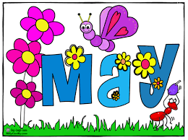
- Conversation
- Rhyme Time
- Learning Values
- Outdoor Activity
- Story Time

Theme : My Family ,Helpers and My Neighbourhood
Montessori activities : Colour Tablets (Box 1),
Drawing insets ( square,Yellow)
Phonics : Phonic Drill (orally) o,u
Written work :
- Number –Revision of previous numbers
- Introduction of 7 , 2
- Tracing pattern- Slanting line and curved line
Craft Activity
Critical Thinking/Sensorial Activity: Full / Empty ,
Open / Shut
Circle Time Activities :
- Conversation
- Rhyme Time
- Learning Values

- Outdoor Activity

Theme : Fruits and Vegetables

Montessori activity : Cylinder blocks (Sensorial),
Mopping/Dusting (EPL),
Drawing insets (Triangle (blue) and Rectangle (green) )
Phonics : Phonic Drill (orally) l ,t
Written work :
- Number – Revision of previous numbers
- Introduction of 3 , 9
- Tracing pattern- Curve(mountain , wave )
- i and u
Craft Activity
Critical Thinking/Sensorial Activity: Odd one out
Circle Time Activities :
- Conversation
- Rhyme Time

- Learning Values
- Outdoor Activity
- Story Time
Theme : Animals : Wild-Farm

(Babies-sounds-Food-Homes)
Montessori activity : Pink Tower (Sensorial),
Pouring solid /liquid,
Phonics : Phonic Drill (orally) p, j , f

Written Activity:
- Number – Revision of previous numbers 1,2,3,7,9
- Phonic – l , t , and revision
Tracing pattern- Tracing pattern ---Hook and candy
Craft Activity
Critical Thinking/Sensorial Activity:
Spot the difference
Circle Time Activities :
- Conversation
- Rhyme Time
- Learning Values
- Outdoor Activity
- Story Time

Theme: Pet-Marine
(Babies-sounds-Food-Homes)
Montessori activity : Brown Stairs, Hot and cold,
sweet and salt,
Phonics : Phonic Drill (orally) c , h , r
Written work :
- Number – 6 , 5 and revision
- Phonic – p ,j ,f , o
- Revision of Previous sounds
Craft Activity
Critical Thinking/Sensorial Activity: Few / Many
Circle Time Activities :
- Conversation
- Rhyme Time
- Learning Values
- Outdoor Activity
- Story Time

Theme: Seasons
Montessori activity : Number Rods, Number Cards,
Phonics : Phonic Drill (orally) b , n , and revision
Numbers : Concept of Zero with activity
Written work :
- Number – 8 and 0
- Phonic – c , h , r
Craft Activity
Critical Thinking/Sensorial Activity: Pairing the Objects.
Circle Time Activities :
- Conversation
- Rhyme Time
- Learning Values
- Outdoor Activity

- Story Time
Theme: Transport and Communication

Safety Measures everywhere
Montessori activities Pouring through funnels,
Taste (sweet and sour),Press Button
Phonics : Phonic Drill (orally) m , d , k
Numbers : Introduction to tens and ones
Written work :
- Number – 10 , writing of 0 to 10 , count and write 1 to 10
- Phonic – a , b , n
- Revision of previous sounds
Craft Activity
Critical Thinking/Sensorial Activity: Personal hygiene and table manners .
Circle Time Activities :
- Conversation
- Rhyme Time
- Learning Values
- Outdoor Activity
- Story Time

Theme: Birds
Phonics : Phonic Drill (orally) g , e , s
Montessori activities : Colour Tablets(Box 2)
Press button(Velcro) ,
Written work :
- Number –, missing numbers and revision of count and write
- Phonic – m , d , k
Craft Activity
Critical Thinking/Sensorial Activity:
Day and Night , Up / Down
Circle Time Activities :
- Conversation
- Rhyme Time
- Learning Values
- Outdoor Activity

- Story Time
Theme: Plant Life and Germination,
Montessori activity : Touch Board,
Phonics : Phonic Drill (orally) s , v , w
Written work :
- Number – after numbers ,
- Phonic – e , g , q , s
Craft Activity
Critical Thinking/Sensorial Activity:
Living and non living
Circle Time Activities :
- Conversation
- Rhyme Time
- Learning Values
- Outdoor Activity

- Story Time
Theme: Flowers
Montessori activities :Revision
Phonics : Phonic Drill (orally) x , y , z
Written work :
- Phonic –y , v , w , x
- Revision of previous sounds
- Numbers : between numbers
Craft Activity
Critical Thinking/Sensorial Activity: Taste / Smell, Wet / Dry
Circle Time Activities :
- Conversation
- Rhyme Time
- Learning Values

- Outdoor Activity
- Story Time
Theme: Insects
Montessori activity : Recap of all activities.
Phonics : Phonic Drill (orally) a to z
Written work :
- Number – Revision of numbers ,
- Phonic – z writing
- Activities on a to z
Craft Activity
Critical Thinking/Sensorial Activity: Healthy / Unhealthy ,
Revision
Circle Time Activities :
- Conversation
- Rhyme Time
- Learning Values
- Outdoor Activity

- Story Time

